Install and Configure Jenkins on a Sushi Operating System

Logging into the system and installing the requirements:
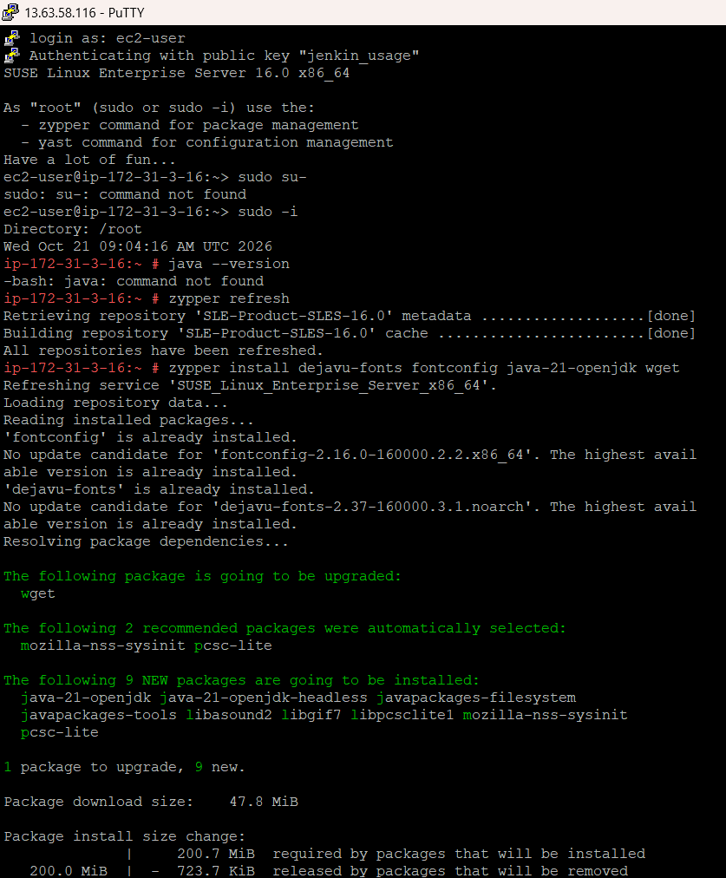
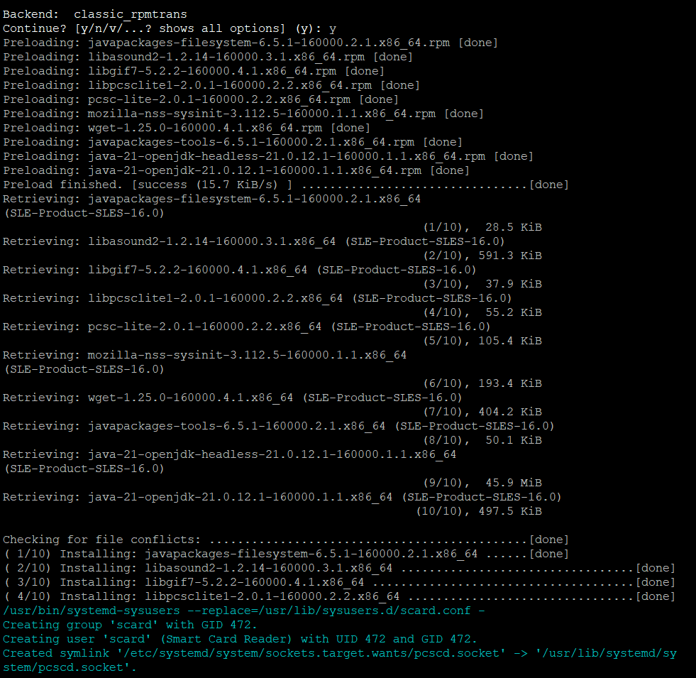
Adding the repository before installation of Jenkins
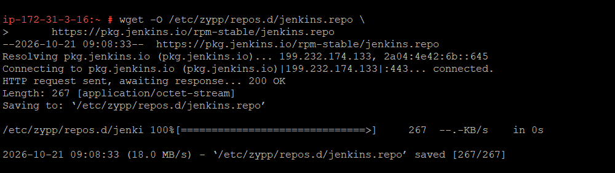

Installing Jenkins
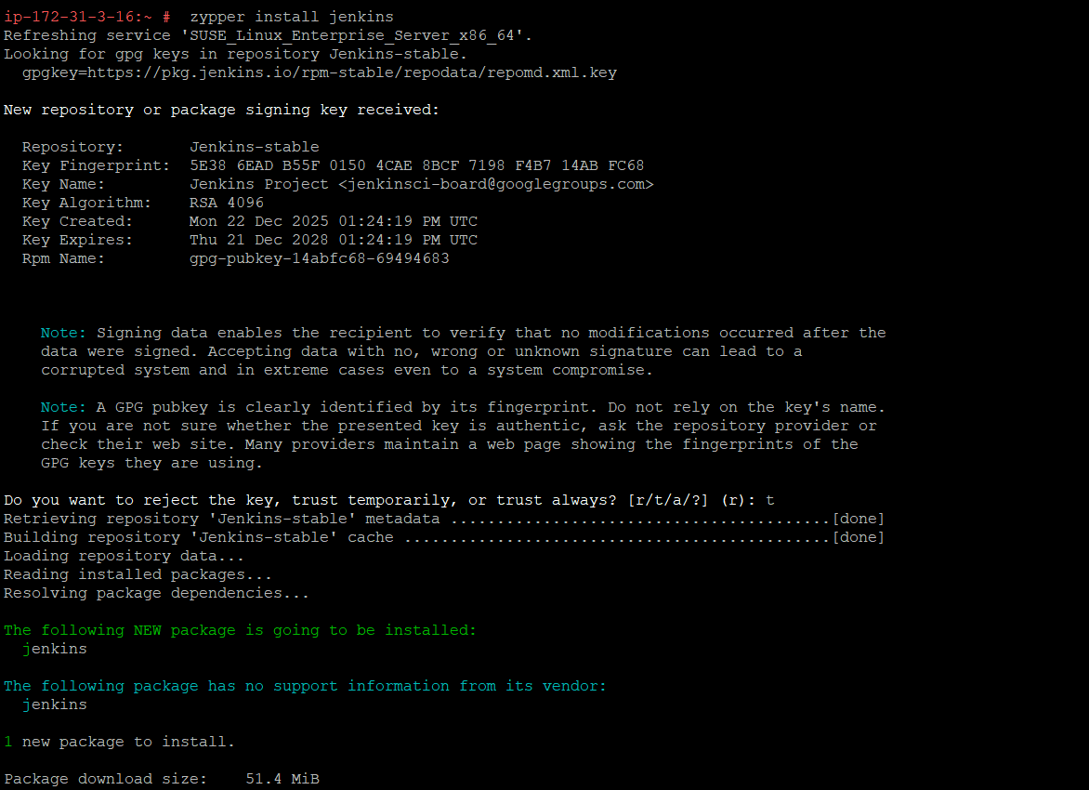

Checking The status whether Jenkins is running or not:
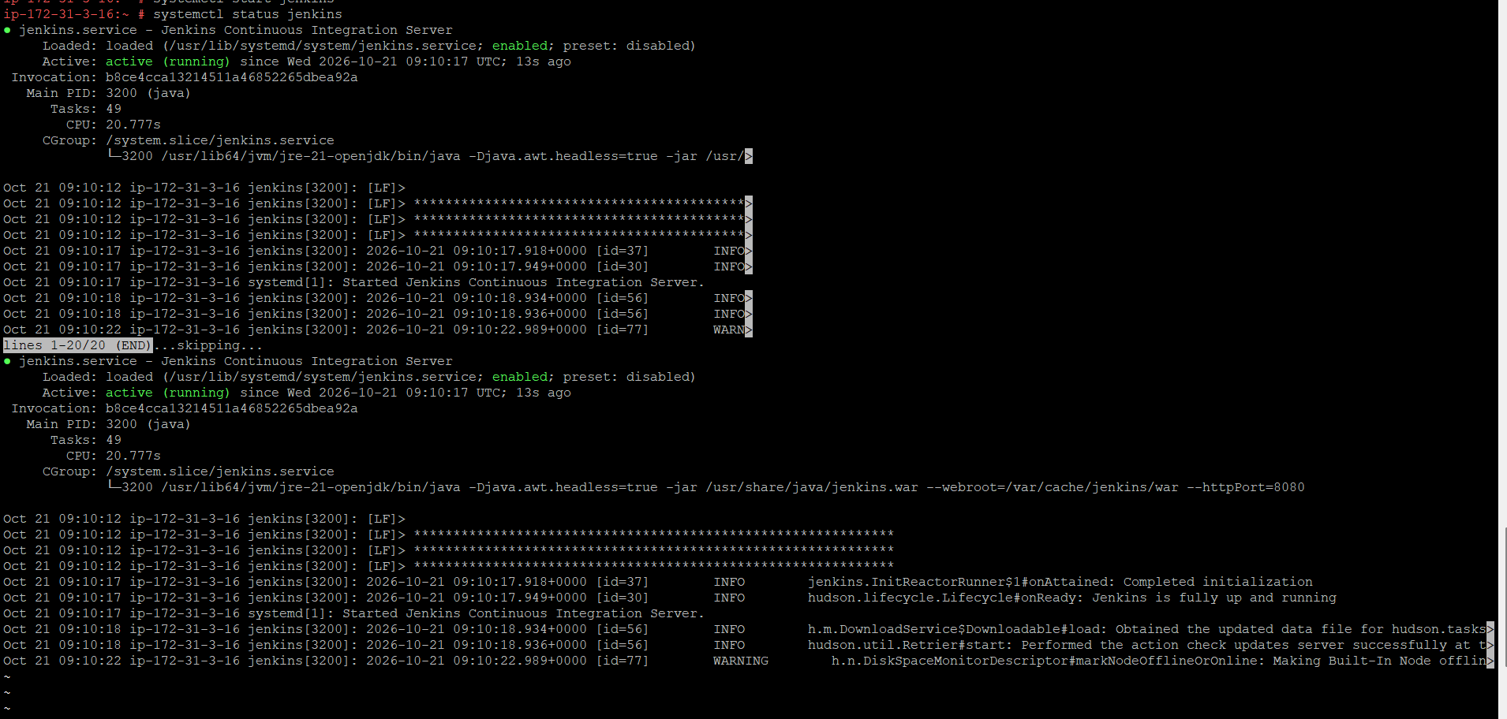

Opening Jenkins in the web-browser
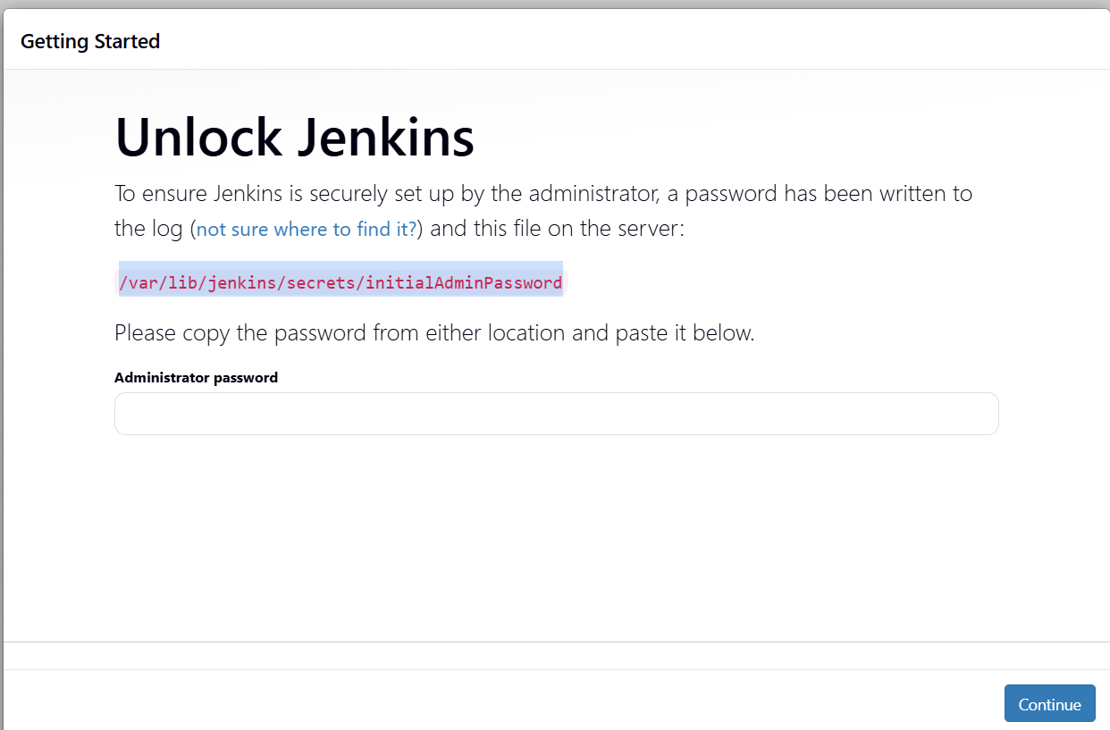
Dowloading Required Plugins

